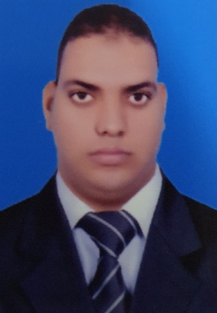
Curriculum Vitae

CAREEROBJECTIVE:

To obtain a rewarding and challenging employment in order to enhance and develop my skill for personal growth to promote and good working relationship among my colleagues.

Personal data:
Name : Mahmoud Fawzy Ali Elkot
Gender : Male
Nationality : Egyptian
Date of Birth : 17-December 1994
Passport Number : A21445483
Address : Abou Thar Al Ghafari Street,Salmiya, Kuwait

Mobile No : 0096560691577
Marital Status : single
Military Service : not required
E-mail : mahmoudfawzy311@gmail.com
Driving license : Valid

Qualifications :
- Bachelor’s Degree Of Commerce Major – managerial Information System
- Higher Education, Computer Science

Languages
Written Spoken
- Arabic Mother tongue Mother tongue
- English Medium level Medium level

Computer Skills
- Data Entry
- Very good Knowledge in using computer.
- Operating Systems, High skills on using computer (Windows, Word, Excel, PowerPoint, Outlook).
- Net browsing

Skills:
- Very good Public Relation
- Ability to use Computers and Printing and Printing all types of forms
- Hard worker and ability to work under pressure.
- Task oriented and creative
- Fast learner & accurate
- Communicative and sociable
- High ability to deal with a wide range of people and ready to deal with multinational.
- Team player, Self-motivated creative.
- Willingness to provide assistance and experience to others.
- Able to understand new systems and training.
- Excellent customer service.
- Able to work varied shifts.
- Able to process cash transactions.

Work Experience:

- Worked As a guest service associate At Millennium Hotel & Convention Center Kuwait 2018 Jun

Millennium Hotel & Convention Center Kuwait: currently working in the F&B Department Handling Different Sections (Jun 26, 2018 till present) :-
- Lamar Restaurant
- El-Publico Restaurant
- In-Room Dinning
- Pool Bar
- Shisha Café
- Library Café

Responsibilities & Achievements:
- Meet and greet the guests.
- Oversee catered function, in house and off site.
- Responsible for making the function space visually appealing and presenting the menu offering of the event.
- Responsible for the overall sanitation and cleanliness of the work area, Restaurant rooms and storage area.
- Maintaining inventory for store, beverage, equipment and upkeep of the department.

- Has Successfully Completed The Cross Training At Front Office Basic Operations In Millennium Hotel& Convention Centre
September 9th 2019 till October 31th 2019

- Sheraton Hotel Sharm El Sheikh Egypt 2016 march

Responsibilities & Achievements:
- Provide excellent customer service and ensure customer needs are met.
- Responsible for operation F&B outlets assigned.
- Handling guest complaints and taking their feedback as well as inviting them for special occasions.
- Follow to be compliance with quality and hygiene standard.
- Try to reach to step up level.

Hobbies:
- Listening to music
- Reading interesting articles
- Learning about the new technologies in the computers field Learning foreign languages and new software

References:

Reference available upon request
Sheriff abdelaziz Sous chef at millennium Kuwait
abdalaziz_sherif@yahoo.com

………………………… ……………………………
Date Signature

