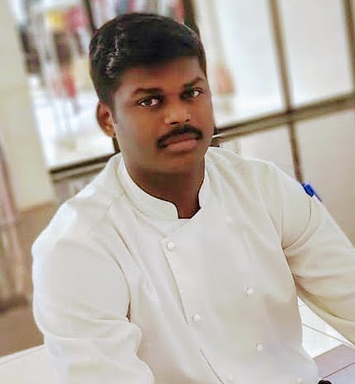 | CONTACT  Mobile: 0561380771/+917845392743  Email Address: ramkumarchandran1991@gmail.com  Current Location: AL Sulaymaniyah street, Riyadh,13515  KUMAR RAMACHANDRAN  Kitchen Manager  Summary of Position:  Directly responsible for all kitchen functions including food purchasing, preparation and maintenance of quality standards; sanitation and cleanliness; training of employees in methods of cooking, preparation, plate presentation, portion and cost control and sanitation and cleanliness.  WORK EXPERIENCE  THE COFFEE CLUB (Middle east)  KITCHEN MANAGER  Saudi Arabia  September 2018-Present  ● Create new recipes for the New Menu to increase option for the  customers.  ● Provided the Management with information about ingredients cost  and correct portioning of meals to help them devise pricing of menu  items.  ● Supervised food preparation and food handling to ensure safety  procedures were followed.  ● Conforming at all times with health and hygiene regulations.  ● Ensuring that the kitchen hits and maintains pre-set profit margins.  ● Ensuring there is a seamless link between the kitchen and the front of  house teams.  ● Spotting talented kitchen staff and then helping to develop them  further.  ● Controlling the kitchens budget and day to day running costs.  ● Interviewing and recruiting new team members.  ● Organizing kitchen staff rotes so that busy periods are covered.  ● Conducting staff appraisals and dealing with any inefficiencies in  performance.  ● Attending and participating in management meetings.  LA BRIOCHE UAE  KITCHEN MANAGER  July 2013-August 2018  ● Created PO within budgetary constraints to maintain optimal  inventory level.  ● Supervised the hiring and training of new kitchen staff and  monitored their development.  ● Optimized quality assurance procedure by efficiently completing  regular line checks.  THE SOUP & SALAD CAFÉ  CHEF  Chennai India  July 2011-December 2012  ● Inspected plated food to ensure quality, quantity and presentation  were excellent.  ● Before each shift checked freezer and refrigerator for temperature  levels and to ensure proper functioning.  BENZZ PARK HOTEL  Chennai India  October 2009-June 2011  ● Ability to motivate teams to produce consistently great food.  ● Experience of working in busy pubs and restaurants.  ● Willing to work bank evenings, weekends and holiday periods such as  Christmas.  ● Can work on own as well as part of a team. • Confident leading a  team and taking responsibility.  ● Passion for good food, good wine and brilliant service.  ● Determined to deliver the best of everything.  ● Responsible for inventory control and order items to keep supplies  sufficient.  EDUCATION  ACE INSTITUTE OF HOTEL  MANAGEMANT  Tamil Nadu, India 2006  Higher National Diploma  AREAS OF EXPERTISE  ● Stock ordering  ● Team motivation  ● Team rotes  ● Business needs Menu development  ● Managing wastage  PROFESSIONAL  Fire Marshall  Key holder  PERSONAL SKILLS  Reliable  Forward thinking  Committed  Hard working  HOBBIES  SWIMMING AND READING BOOKS  Language: English, Tamil, Hindi.  Personal Details:  Nationality: Indian  Gender: Male  Date of Birth: October 28,1990  Marital Status: Single  Passport Details:  Number: K4028513  Place of Issue: Madurai  Date of Issue: 25/5/2012  Expiry Date: 21/5/2022

