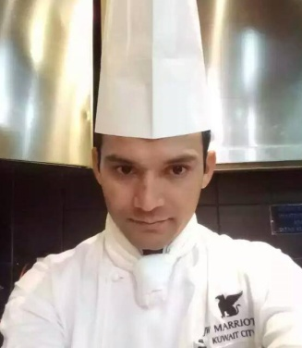
Lal bahadur sarki
Tanahun Nepal
Reggai, Kuwait
Contact No. : 66812799 (whatsapp)
Email Add: sarki.lal55@gmail.com

Designation apply for : chef de parties

Core Competencies:

Meals Preparation | Proper Portioning | Garnishing
Food logs maintenance | Regulating Temperature | Quality Monitoring

Culinary Expertise:
Specializing in Continental fine dining cuisine, good knowledge in Indian, Arabic, Continental, Italian & Asian Foods, Professional qualification in executive meal planning, eye appealing food presentation etc.

achievement/training:
- Basic Hotel Training Course at Kantipur Hotel Training Center Nepal.
- Letter of appreciation.
- In the beginning certificate
- Symphony of service
- Best Employee of the month.
- Basic fire awareness course.
- HACCP Course
- Culinary Foundations Lebel 1
- Great Food Safe Food Training
- Culinary Expert.

WORK EXPERIENCES:

- Currently working as a Demi Chef De Parties at ALSHAYA Group PF CHANGS Branch from 29thDecember 2017 to till date.
- Worked experienced as a COMMIS First {I} at JW Marriott Hotel Kuwait City from 18thMay 2013 to 17th November 2017.
- Worked experienced as a Service Crew at Qatar Fuel WOQOD from 06th July 2009 to 30th June 2012.
- Worked experienced as a kitchen Helper at The Oasis Cafe KTM Nepal from 25th February 2007 to 28th June 2009.

Duties and Responsibilities:
- Assisting All COMMIS
- To Assume overall Responsibilities Chef De Parties absence.
- Managed food preparation processes.
- Ensured all station were properly set prior to service.
- Checked Garnish and Meal presentation.
- Checked and maintained stock level.
- Ensured all chiller, deep freezer and food storage areas were maintained.
- Made sure all stations in the kitchen were clear and up to the standard level.
- Maintained FIFO.
- Checked food expiry and discard any outdated food.
- Ensured good customer relations were maintained at all time.
- Providing training and experience to staff to the quality standard of the department.
QUALIFICATIONS:
- Intermediate Certificate

Skills:
- Team Work/Cooperation
- Self Development
- Well Groomed
- Listening and Oral Skills.
- Pleasant Personality
- Punctuality

Personal Details :

Date of Birth : 08/01/1988
Nationality : Nepalese
Gender : Male
Languages : Nepali, English, Hindi & Arabic
Visa Status : Article No. 18 –transferable

Thanking you ,

Lal Bahadur Sarki

